**Question: Design a responsive web-page for laptop, tablet and mobile.**

**Code:**

**Index.html**

<!doctype html>

<html lang="en">

<head>

<meta charset="UTF-8">

<meta name="viewport"

content="width=device-width, user-scalable=no, initial-scale=1.0, maximum-scale=1.0, minimum-scale=1.0">

<meta http-equiv="X-UA-Compatible" content="ie=edge">

<title>Document</title>

<link rel="stylesheet" href="css/style.css">

<link rel="stylesheet" href="https://use.fontawesome.com/releases/v5.7.2/css/all.css" integrity="sha384-fnmOCqbTlWIlj8LyTjo7mOUStjsKC4pOpQbqyi7RrhN7udi9RwhKkMHpvLbHG9Sr" crossorigin="anonymous">

</head>

<body>

<header>

<div class="wrapper">

<div class="navigation">

<div class="logo">Projection by TEMPLATED</div>

<nav class="navigation-menu" id="hamburger">

<ul>

<li><a href="#">Home</a></li>

<li><a href="#">Generic</a></li>

<li><a href="#">Elements</a></li>

</ul>

</nav>

<span class="hamburger-menu-icon" onclick="myFunction()"><i class="fas fa-bars"></i></span>

</div>

<div class="header-content">

<div class="header-content-heading">Welcome to Projection</div>

<div class="header-content-demo">

<div class="header-content-demo-repeat">

<i class="fas fa-car-alt"></i>

<div class="header-content-demo-repeat-heading">Aliquam</div>

<div class="header-content-demo-repeat-content">Suspendisse amet ullamco</div>

</div>

<div class="header-content-demo-repeat">

<i class="fas fa-camera"></i>

<div class="header-content-demo-repeat-heading">Elementum</div>

<div class="header-content-demo-repeat-content">class aptent taciti ad litora</div>

</div>

<div class="header-content-demo-repeat">

<i class="fas fa-bug"></i>

<div class="header-content-demo-repeat-heading">Ultrices</div>

<div class="header-content-demo-repeat-content">Nulla vitae mauris non felis</div>

</div>

</div>

<button class="get-started">Get Started</button>

</div>

</div>

</header>

<section class="section">

<div class="wrapper">

<div class="section-content">

<div class="section-content-both">

<img src="assets/pic01.jpg" alt="Picture 1">

<div class="section-content-both-heading">Lorem ipsum dolor sit amet.</div>

<div class="section-content-both-content">Lorem ipsum dolor sit amet, consectetur adipisicing elit. Dolor doloribus eius harum illum incidunt laborum minima molestias neque officia placeat.</div>

<button class="get-started">LEARN MORE</button>

</div>

<div class="section-content-both">

<img src="assets/pic02.jpg" alt="Picture 2">

<div class="section-content-both-heading">Lorem ipsum dolor sit amet.</div>

<div class="section-content-both-content">Lorem ipsum dolor sit amet, consectetur adipisicing elit. Dolor doloribus eius harum illum incidunt laborum minima molestias neque officia placeat.</div>

<button class="get-started">LEARN MORE</button>

</div>

</div>

</div>

</section>

<footer class="footer">

<div class="wrapper">

<div class="get-in-touch">Get in touch</div>

<form action="#">

<div class="form-input-half-left">

<label for="name">Name</label>

<input type="text" placeholder="Name">

</div>

<div class="form-input-half-right">

<label for="email">Email</label>

<input type="email" placeholder="Email">

</div>

<div class="form-input-full">

<label for="message">Message</label>

<textarea name="message" id="message" cols="30" rows="10" placeholder="Message" ></textarea>

</div>

<button class="send-message-button">SEND MESSAGE</button>

</form>

</div>

<div class="copyright-footer">&copy; 2019: kamal</div>

</footer>

<script src="js/jquery-3.3.1.min.js"></script>

<script>

// $(document).ready(function(){

// $('.hamburger-menu-icon').click(function(){

// $('.navigation-menu').css("display" , "block");

// })

// })

function myFunction() {

document.getElementById("hamburger").classList.toggle("hamburger-menu-icon-show");

}

</script>

</body>

</html>

**Style.css**

/* http://meyerweb.com/eric/tools/css/reset/

v2.0 | 20110126

License: none (public domain)

*/

html, body, div, span, applet, object, iframe,

h1, h2, h3, h4, h5, h6, p, blockquote, pre,

a, abbr, acronym, address, big, cite, code,

del, dfn, em, img, ins, kbd, q, s, samp,

small, strike, strong, sub, sup, tt, var,

b, u, i, center,

dl, dt, dd, ol, ul, li,

fieldset, form, label, legend,

table, caption, tbody, tfoot, thead, tr, th, td,

article, aside, canvas, details, embed,

figure, figcaption, footer, header, hgroup,

menu, nav, output, ruby, section, summary,

time, mark, audio, video {

margin: 0;

padding: 0;

border: 0;

font-size: 100%;

font: inherit;

vertical-align: baseline;

}

/* HTML5 display-role reset for older browsers */

article, aside, details, figcaption, figure,

footer, header, hgroup, menu, nav, section {

display: block;

}

body {

line-height: 1;

}

ol, ul {

list-style: none;

}

blockquote, q {

quotes: none;

}

blockquote:before, blockquote:after,

q:before, q:after {

content: '';

content: none;

}

table {

border-collapse: collapse;

border-spacing: 0;

}

*{

box-sizing: border-box;

}

body{

width: 100%;

font-family: 'Roboto', sans-serif;

}

.clearFix {

clear: both;

content: "";

display: table;

}

.wrapper{

width: 90%;

margin: auto;

}

header{

background-image: url("../assets/banner.jpg");

background-repeat: no-repeat;

background-size: cover;

height: 600px;

position: relative;

color: #fff;

text-align: center;

z-index: 1;

}

header:before {

content: '';

background: #52515a;

opacity: 0.8;

position: absolute;

width: 100%;

height: 100%;

top: 0;

left: 0;

z-index: -1;

}

.navigation{

height: 100px;

line-height: 100px;

border-bottom: 1px solid #fff;

}

.navigation-menu ul li{

display: inline;

margin-right: 20px;

}

.navigation-menu ul li:last-child{

margin-right: 0;

}

.navigation-menu ul{

float: right;

}

.logo{

float: left;

}

.navigation-menu ul li a{

text-decoration: none;

color: #fff;

}

.hamburger-menu-icon{

float: right;

display: none;

}

.header-content{

padding:10% 10%;

}

.header-content-heading{

font-size: 40px;

}

.header-content-demo {

padding-top: 5%;

}

.fas{

font-size: 40px;

color: #67a483;

}

.header-content-demo-repeat-heading{

font-size: 20px;

font-weight: bold;

line-height: 50px;

}

.header-content-demo-repeat-content{

font-weight: bold;

color: #868686;

}

.header-content-demo-repeat{

display: inline-block;

width: calc(100%/3 - 6px);

border-right: 2px solid #626262;

}

.header-content-demo-repeat:last-child{

border-right: none;

}

.get-started{

margin-top: 30px;

background-color: transparent;

color: #67a483;

font-size: 15px;

padding: 10px 40px;

border: 2px solid #67a483;

border-radius: 30px;

text-transform: uppercase;

}

.section{

width: 100%;

text-align: center;

background-color: #fff;

height: 500px;

padding-top: 3%;

}

.section-content{

width: 100%;

}

.section-content-both{

display: inline;

width: 50%;

padding: 0% 8%;

}

.section-content-both img{

border-radius: 50%;

}

.section-content-both-heading{

font-size: 30px;

padding: 5% 20%;

color: #626262;

}

.section-content-both-content{

line-height: 25px;

}

.section-content-both:last-child{

float: right;

}

.section-content-both:first-child{

float: left;

}

.footer{

background-color: #67a483;

height: 600px;

color: #fff;

text-align: center;

padding: 5% 0;

}

.get-in-touch{

font-size: 30px;

text-align: center;

}

.form-input-half-left{

width: calc(100%/2 - 2px);

display: inline-block;

padding-right: 10px;

}

.form-input-half-left>input{

width: 100%;

background-color: transparent;

padding: 2%;

color: #b4b4b4;

border: 1px solid #b4b4b4;

border-radius: 5px;

}

label{

display: block;

text-align: left;

line-height: 50px;

font-weight: bold;

}

.form-input-half-right{

width: calc(100%/2 - 3px);

display: inline-block;

padding-left: 10px;

}

.form-input-half-right>input{

width: 100%;

background-color: transparent;

padding: 2%;

color: #b4b4b4;

border: 1px solid #b4b4b4;

border-radius: 5px;

}

.form-input-full{

width: 100%;

}

textarea{

width: 100%;

background-color: transparent;

padding: 2%;

color: #b4b4b4;

border: 1px solid #b4b4b4;

border-radius: 5px;

resize: none;

}

::placeholder{

color: #b4b4b4;

}

.send-message-button{

border: 2px solid #fff;

color: #fff;

margin-top: 30px;

background-color: transparent;

font-size: 15px;

padding: 10px 40px;

border-radius: 30px;

}

.copyright-footer{

margin-top: 2%;

font-size: 12px;

color: #e4e4e4;

font-weight: bold;

}

/*........................For Tablet Device.....................*/

@media (max-width: 1120px){

.section-content-both{

width: 100%;

}

.section{

height: 920px;

}

.section-content-both:last-child{

padding-top: 50px;

}

.form-input-half-left{

width: 100%;

padding: 0;

}

.form-input-half-right{

width: 100%;

padding: 0;

}

header{

height: 550px;

position: relative;

}

.navigation-menu{

position: absolute;

top: 0;

right: 0;

display: none;

}

.hamburger-menu-icon-show{

display: block;

}

.hamburger-menu-icon{

display: block;

cursor: pointer;

}

.navigation nav ul{

margin-top: 60px;

}

.navigation nav ul li{

display: block;

width: 200px;

line-height: 50px;

border-bottom: 1px solid #fff;

background-color: #67a483;

margin-right: 20px;

}

}

/*........................For Mobile Device.....................*/

@media (max-width: 768px){

.header-content-demo-repeat{

width: 100%;

padding-top: 30px;

}

header{

height: 750px;

}

}

**Output:**

**Desktop View:**

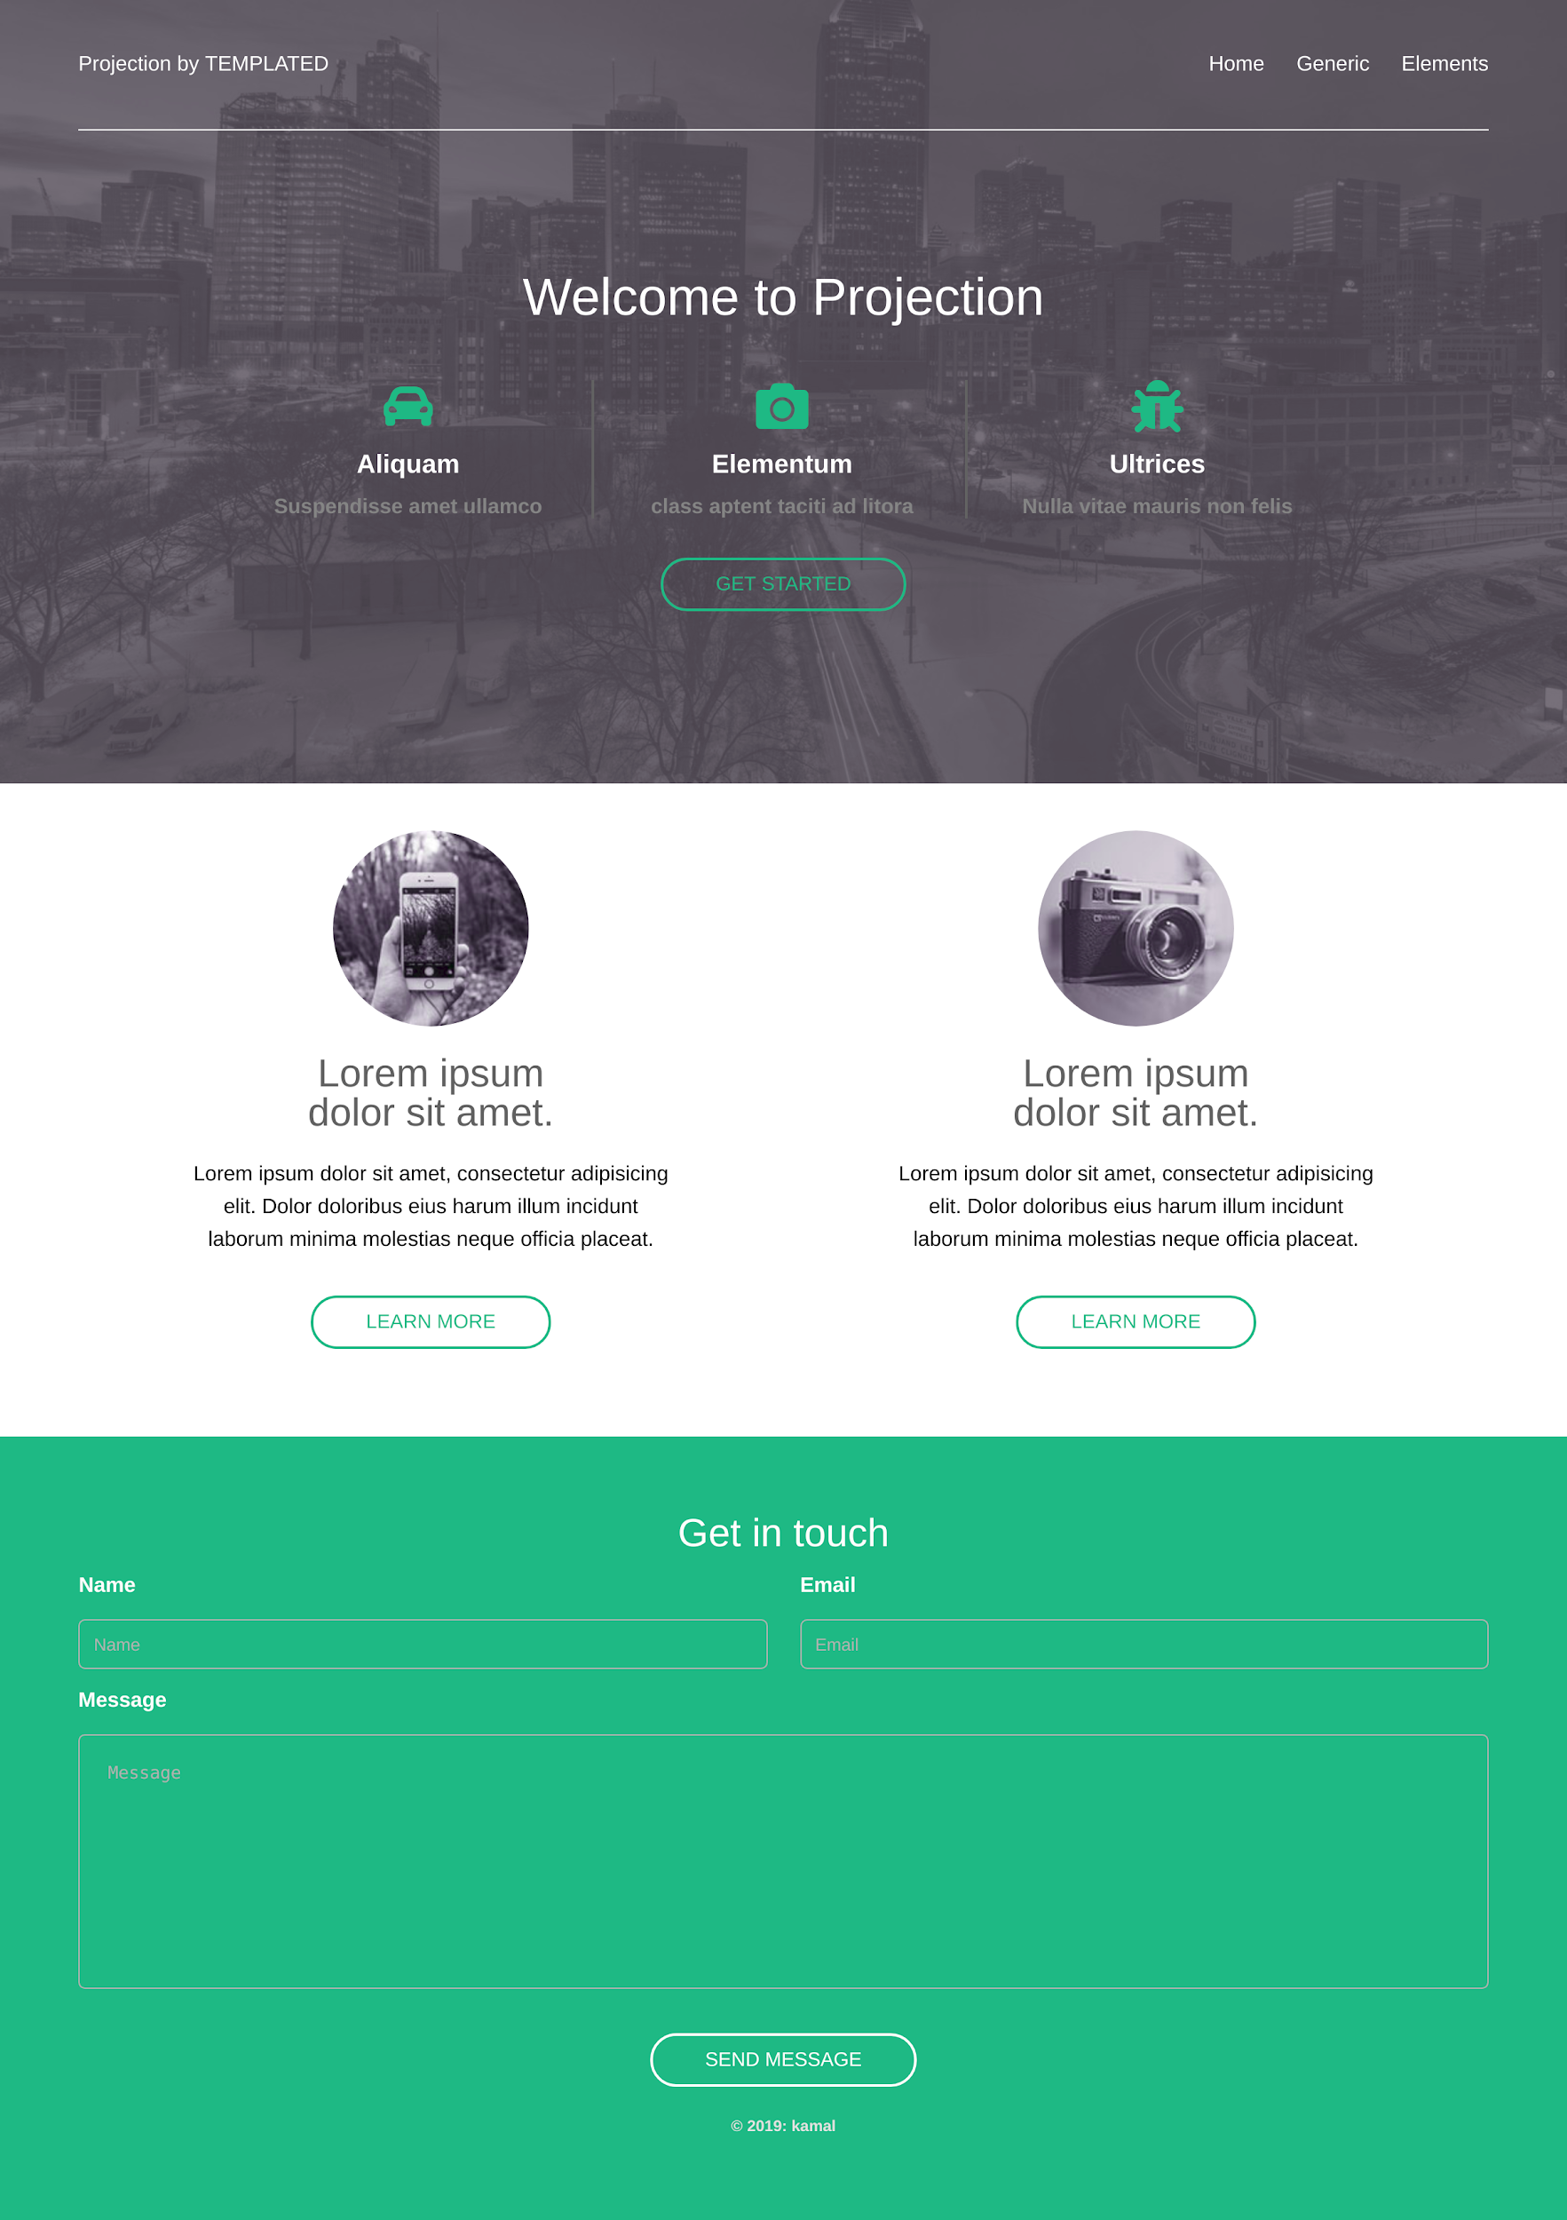

**Tablet View (Please Refer github for complete output image):**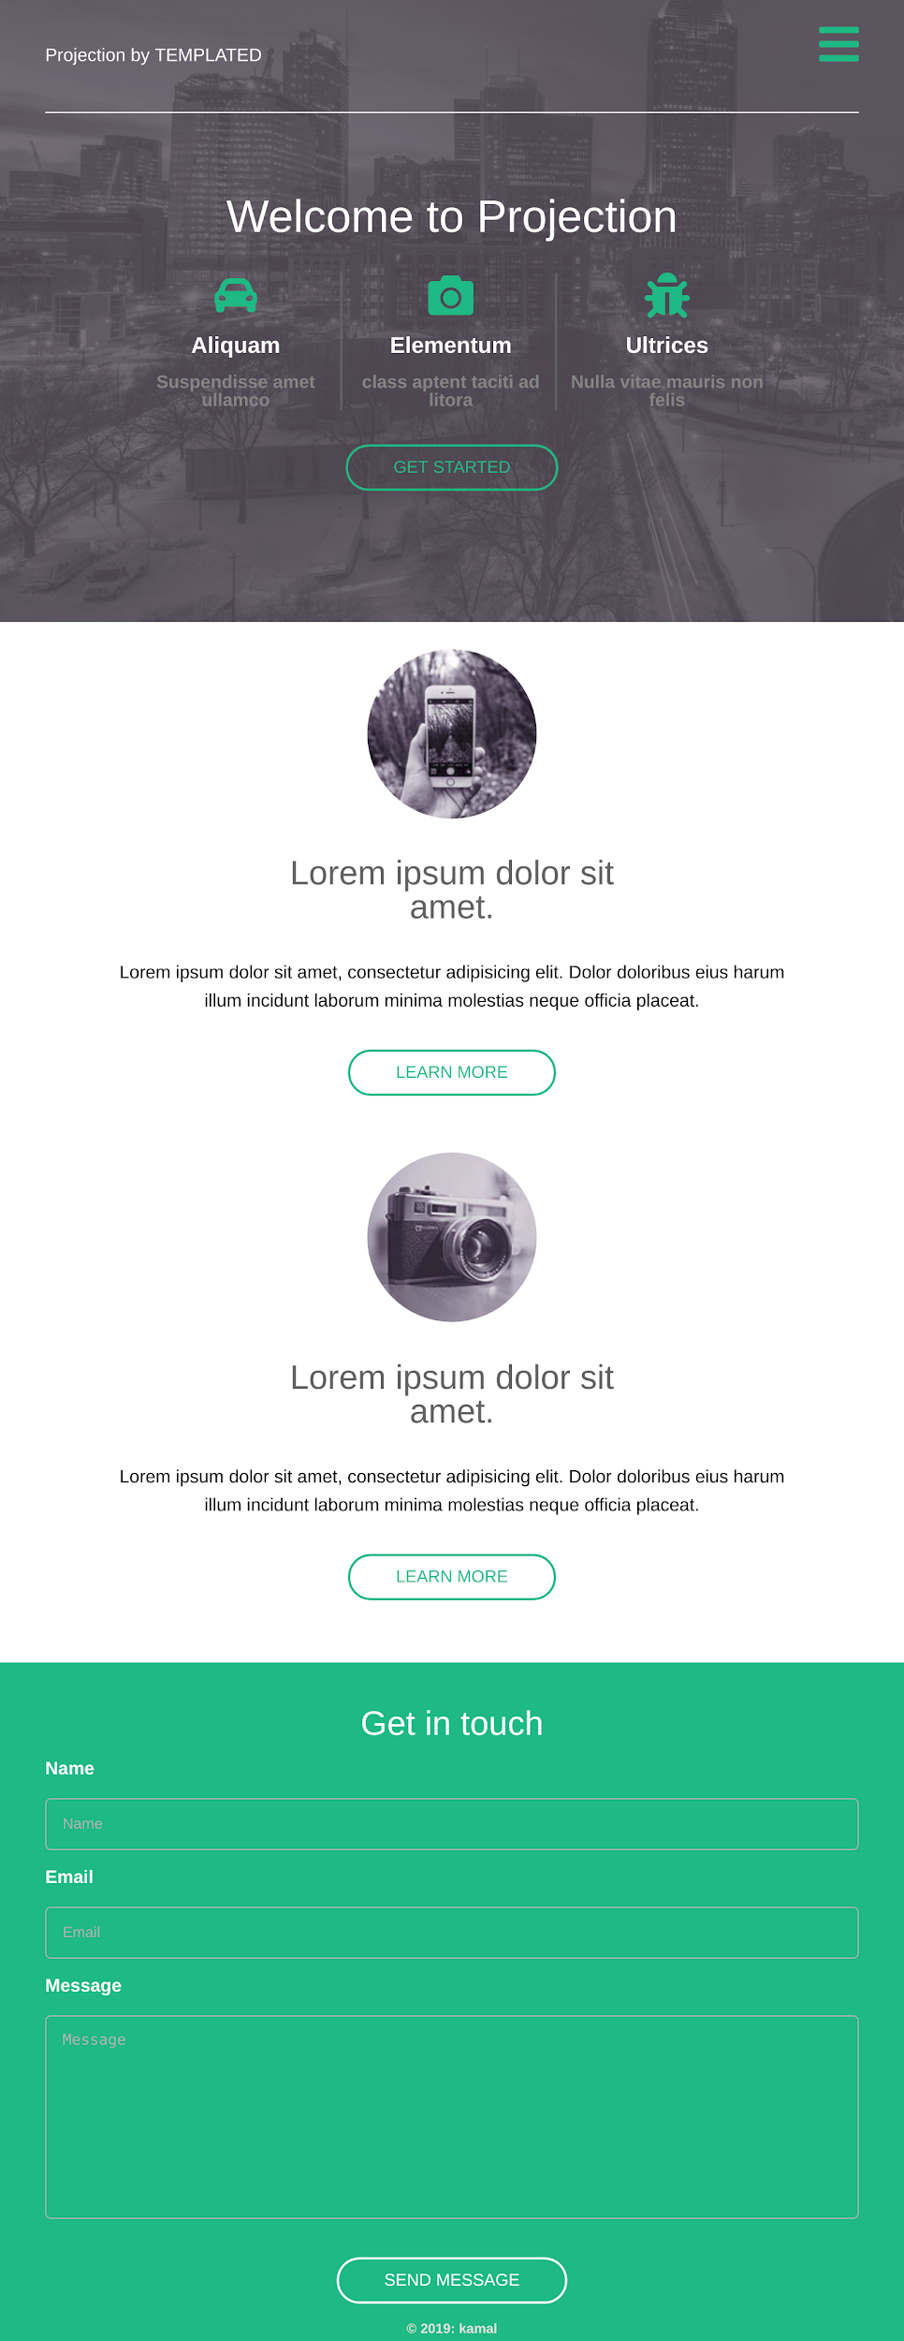

**Mobile View (Please refer github account for complete output image):**

